Project 2 Proposal

Tolly Smith, Yang Liu, Bill Schreiber, Justin Roth

1. A brief articulation of your chosen topic and rationale

Our chosen topic is US Birth data for the year 2018. We chose this data to have a nice visualization of births across the country. It will give us the ability to do drop menus to pick by state,

A link to your data set(s) and a screenshot of the metadata if it exists.    <https://www.cdc.gov/nchs/data_access/vitalstatsonline.htm#Downloadable>

3 or 4 screenshots of relevant, “inspiring” visualizations that frame your creative fodder

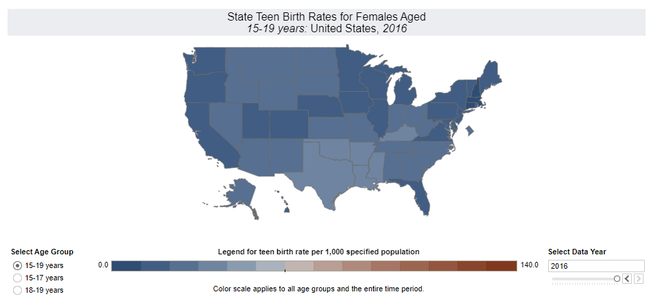

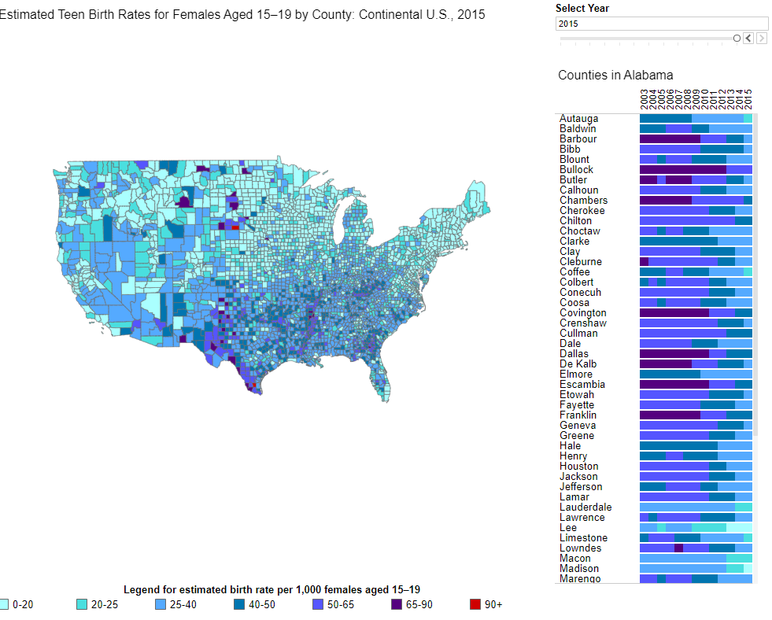

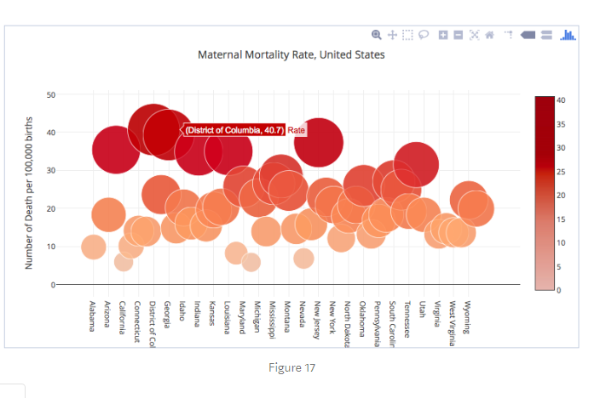   
A sketch of the final design

A link to the primary GitHub repository you’ll be housing your work in

<https://github.com/roth424/Birth-Data-Visualization>